Trial Paper 2 Jan06 intake

  - Any three - each 1 mark
- Micrometer
- Zero error
- Repeated measurement along the wire & average
- Repeated measurement at different angles & average

  - Percentage uncertainty 2 sig. fig is accepted
Absolute and fractional uncertainty strictly 1 sig. fig.
    - 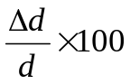 = 4.8% or 5% [1 mark]
    - 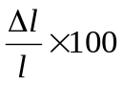 = 0.32% or 0.3 % [1 mark]
    - 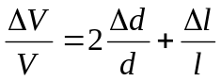= 9.8% or 10 % [2 mark]

    - horizontal velocity = horizontal distance / time
d = v cosθ. t [1 mark]

    - in terms of g.. only vertical motion is affected by g

s = ut + ½ at²
0 = vsinθ.t – ½ gt²
0 = t (vsinθ – ½ gt)
t= 2 v sinθ / g

Or, v = u +at’
When reaching max point, v =0
0= vsinθ - gt’
t'= vsinθ/g
t = 2t’ [1 mark]

  - 32.1º or 57.9º [1 mark]
  - Larger ( due to AR, the path is shorter and lower) [1 mark]

  - In an elastic collision, total kinetic energy of a system is conserved.
[1 mark]
Remarks: Relative speed of separation = r.s of approach is a subsequent result from the principles of conservation of KE and momentum.
Total momentum is always even in inelastic collision as long as there is no external force acting on the system.
Key concept distinguishes inelastic and elastic collision is the conservation of Kinetic energy (not energy but specifically KE)
  - Inelastic, [1 mark]
Part of the bullet’s KE is converted to:
- KE of target (when it moves together with the bullet)
- Any two forms of energy
- Each 1 mark
- No reason required
- Heat energy (when bullet embeds..)
- Internal energy of both…
- Sound energy
- GPE of bullet and target (when bullets strikes a vertically suspended target and both move up)

  - Resultant force along any direction = 0 [1 mark]
Resultant moment about any point = 0 [1 mark]

Comment on these answers:
- Forces acting on the object must balance each other in all direction
- Force acting on the object must form a triangle
- No external force acting…
- The object is either in stationary or moving with a constant speed

600N
D
T
35º

Correct diagram [1 mark]
Closed diagram [1 mark]
label correctly [1 mark]

    - Range of answer (420±10)N [1 mark]
Double check by using tan 35 = …

  - Sum of KE and PE [1 mark]
of ALL the molecules of the system [1 mark]

Supplementary points?

    - Internal energy increases [1 mark]
PE or separation between molecules increases [1 mark]
Or bonds are weakened

Comment on this:
KE increases, molecules vibrate fast till bonds are broken
Not broken but weakened as intermolecular forces exist between molecules

    - Internal energy of water decreases as [1 mark]
Temperature of water decreases Or [1 mark]
KE of water is transferred to ice

    - 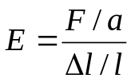
Working [1 mark]
F =0.15 N [1 mark]

Mistakes:
- in converting mm² to m²
- Or forgot to convert
- thought 0.2 mm is the length

    - 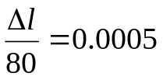 [1 mark]
Δl = 0.040 cm [1 mark]
It’s unnecessary to use to find extension
F/N
x/cm
0
0.040
0.15 N
polythene
Mild steel ( must be very steep to show the great difference in Young modulus)

Sketch:
Qualitative aspects
- Line or curve
- Label axes
- +ve or −ve gradient
Quantitative aspects
- Pass through origin
- Turning point/ end point
- Proportion

    - W= ½ Fx (obeys Hooke’s law) = 3 x 10 ⁻⁵ J [1 mark]
Mistakes:
- Convert cm to m
- W= Fx ( not a constant force but varying)

  - 0.3 mm to 3 mm [1 mark]
Which is comparable to wavelength, width or spacing of slit??

Fringe separation x unchanged [1 mark] | according to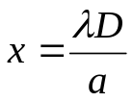…
Contrast increases  [1 mark] | more light energy enters  bright fringe brighter, dark fringe stays dark  either one reason[1 mark]

Fringe separation x increase [1 mark] | according to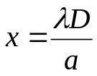… distance between the screen and slits D increase, separation x increases [1 mark]
Contrast decreases [1 mark] | Bright fringes less bright as Intensity is inversely proportional to the distance D [1 mark]

Common mistakes:
- Symbols without definition
- Forgot to explain about contrast
- Dark fringe gets darker
- Fringes become clearer
- Contrast becomes brighter

    - 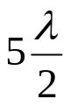= 120 cm [1 mark]
λ=0.48 m [1 mark]

    - v = fλ = 57.6 ms⁻¹ [1 mark]
Additional question: what is the significance of this speed??

  - Ratio of p.d. across the conductor to the current flowing through it
[1 mark]
Definition (something which is measurable) not generally meaning
Not other formula
Additional question: Why R = V/I and not R = ρl/A?

    - Magnitude of change = |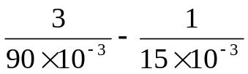| = 33.4 Ω [3 mark]
Common mistakes:
- Calculating the gradient
- Overlook mA
- Answer in fraction (must be decimal figure)

    - thermistor or semiconductor diode [1 mark]

 | A | B  Parallel to the source, p.d. = 4V  use V = I R to find I  then, P= VI
V | 4 | 4
A | 1 | 2
P | 4 | 8
[3 marks]
- For a nucleus,
    - 26
    - 30
    - 0
    - 56 x 1.66 x10⁻²⁷ = 9.30 x10⁻²⁷ [4 Mark]
Mass of 1 proton ≈ mass of 1 neutron ≈ 1.66 x10⁻²⁷(unified atomic mass constant)

** Mistake is simply another way of doing things **
** But make sure when we lose, don’t lose the lesson **

